NAME: S, Guru Deepika
REG NO:192572108
COURSE: CSA1209 Computer Architecture

EXPERMENT-1

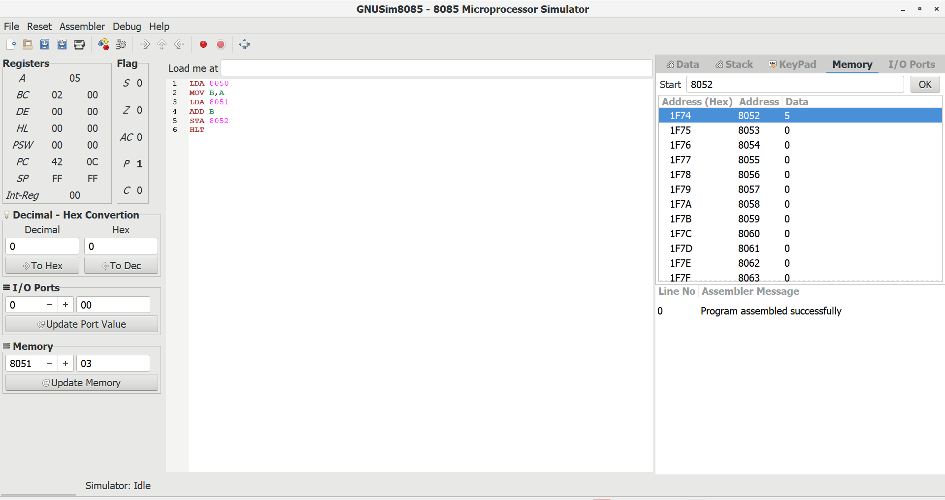

EXPERIMENT-2

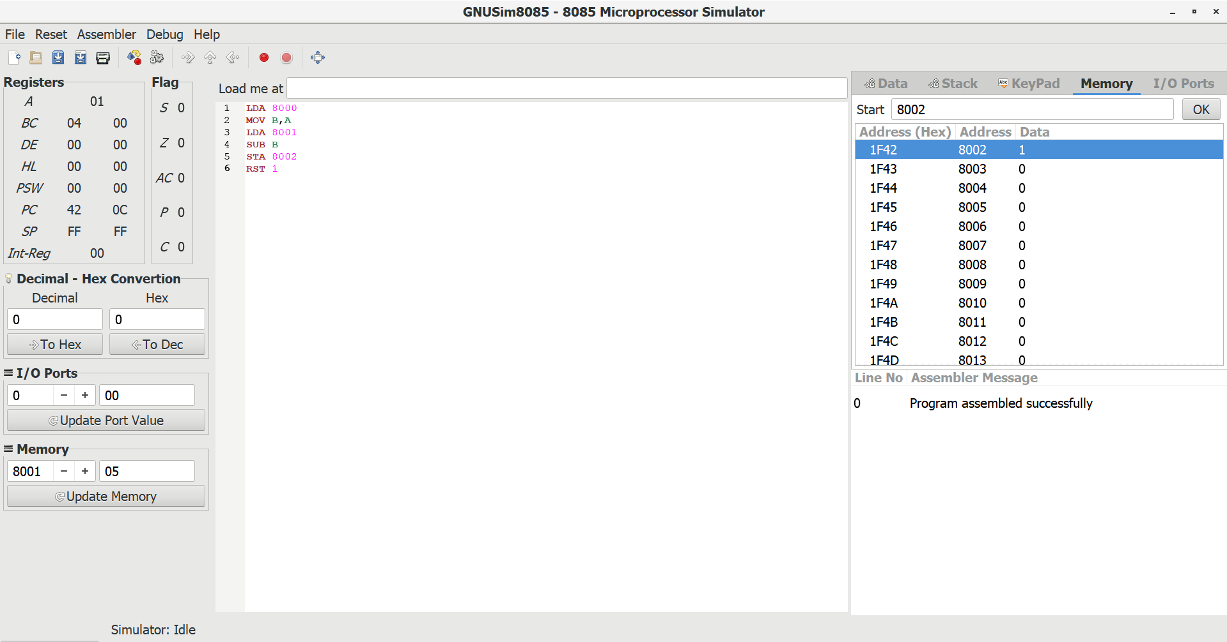

EXPERIMENT-3

